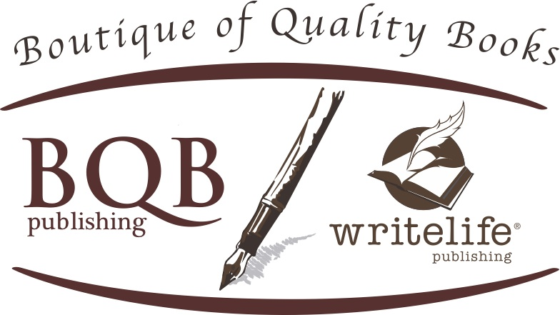
Media Contact:
Terri Leidich
678-316-4150
terri@bqbpublishing.com

BOOK REVIEW INFORMATION

AUTHOR: Mark Paul Smith

TITLE: Honey and Leonard

PUBLISHER: BQB Publishing (an imprint of Boutique of Quality Books Publishing)

PUBLISHER CONTACT INFORMATION: Terri Leidich

PUBLISHER ADDRESS: 960 Oaktree Blvd, Christiansburg, VA 24073

PUBLISHER PHONE #: 678-316-4150

DISTRIBUTOR: IPG, www.ipgbook.com

DATE OF PUBLICATION: November 1, 2019

INTENDED AUDIENCE: Adult

CATEGORY: Women’s Fiction/Romance

PRINT PRICE: US $16.95; CANADA $22.95 EBOOK PRICE: US $7.99;

NUMBER OF PAGES: 342

ISBN: 978-1-945448-47-8 (p); 978-1-945448-48-5 (e)

LCCN: 2018966620

No illustrations, index, or bibliography included

